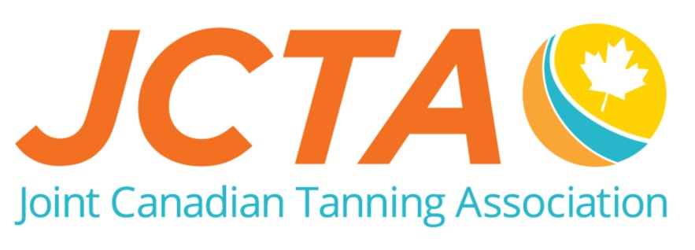
FULL MEMBERSHIP APPLICATION
(PLEASE PRINT)
COMPANY NAME: _______________________________________________________
(what you wish to appear on membership certificate)

CONTACT PERSON: _______________________________________________________
SALON/SHIPPING ADDRESS:

BILLING ADDRESS (IF DIFFERENT):
ADDRESS:
CITY:
PROVINCE: |  | POSTAL CODE:
PHONE:

ADDRESS:
CITY:
PROVINCE: |  | POSTAL CODE:
SALON PH:

WHAT SERVICES DO YOU OFFER? UV Tanning, Spray Tanning, Spa Services

E-MAIL ADDRESS: |  | How did you hear about the JCTA?
WEBSITE ADDRESS  or Google+/Facebook: |  | If it was a distributor, what was the rep’s name?

MEMBERSHIP CATEGORIES AND PAYMENT INFORMATION

Full Membership (Salon membership – One membership per location - All Equipment based on per location)
JCTA ONLY MEMBERSHIP - Please select the member level by checking the appropriate box
- Under 5 pieces of Tanning Equipment – incl $44.00 to fund research and advocacy of the benefits of UV light ............$109.00
- 5 to 10 pieces of Tanning Equipment – incl $94.00 to fund research and advocacy of the benefits of UV light ...…….…$209.00
- 11 pieces and above of Tanning Equipment – incl $144.00 to fund research and advocacy of the benefits of UV light...$309.00
- Free 2-week trial for access to the Members Only Area on the JCTA website at www.TanCanada.org
OR SELECT A COMBINATION MEMBERSHIP BELOW TO RECEIVE INSURANCE DISCOUNT
Contact LMS Prolink for your JCTA Insurance Program pricing at 800-663-6828 or Email: JCTA@lms.ca
- Under 5 pieces of Equipment plus Smart Tan Membership - $44.00 included for research & advocacy…….….$389.00
- 5 to 10 pieces of Equipment plus Smart Tan Membership – $94.00 included for research & advocacy……..….$489.00
- 11 pieces & Up of Equipment plus Smart Tan Membership –$144.00 included for research & advocacy……....$589.00
- Add Smart Tan in-salon advertising package: 6 Posters (20x30), 4 Bed Tents,10 Brochures - $15 + $30 ship… $ 45.00
Payment Type
- Monthly payments instead of lump sum – credit cards only
- CHECK ENCLOSED or VISA MC

Credit Card #_________________________________________________________

Exp.Date_____________ Name On Card___________________________________
SUBTOTAL | $
PLUS MB SK AB GST 5% | $
BC GST 5%/ PST 7% on Smart Tan portion  (add $19.25 for PST) | $
Or HST ON 13%  Or HST NS, NB, PE, NL15% | $
TOTAL | $

I hereby agree to have the Joint Canadian Tanning Association (JCTA) represent my salon with regards to any provincial or federal proposed regulations and or guidelines for the tanning industry. To follow professional standards set out on www.TanResponsible.ca and the JCTA bylaws and constitution.

SIGNATURE (required): __________________________________________
THANK YOU FOR YOUR SUPPORT
For Further Information Contact Steve Gilroy, Executive Director
1951 Abel Street, Kelowna BC, V1Z 3C6 Email: info@TanCanada.org , PH: 800.915.0367 Fax 250-769-4748

